PROJECT REPORT TEMPLETS

OVERVIEW

A retail management application built using Salesforce is a software solution that helps retailers manage their operations, including sales, inventory, customer relationships, and marketing. The application is built on the Salesforce platform, which provides a centralized location for data storage and management, as well as tools for customization, automation, and integration with other systems

PURPOSE

retail management application built using Salesforce can help retailers to improve their operations, increase efficiency, and provide better customer service.

PROBLEM DIFINE DESIGN THINKING

EMPATHY MAP

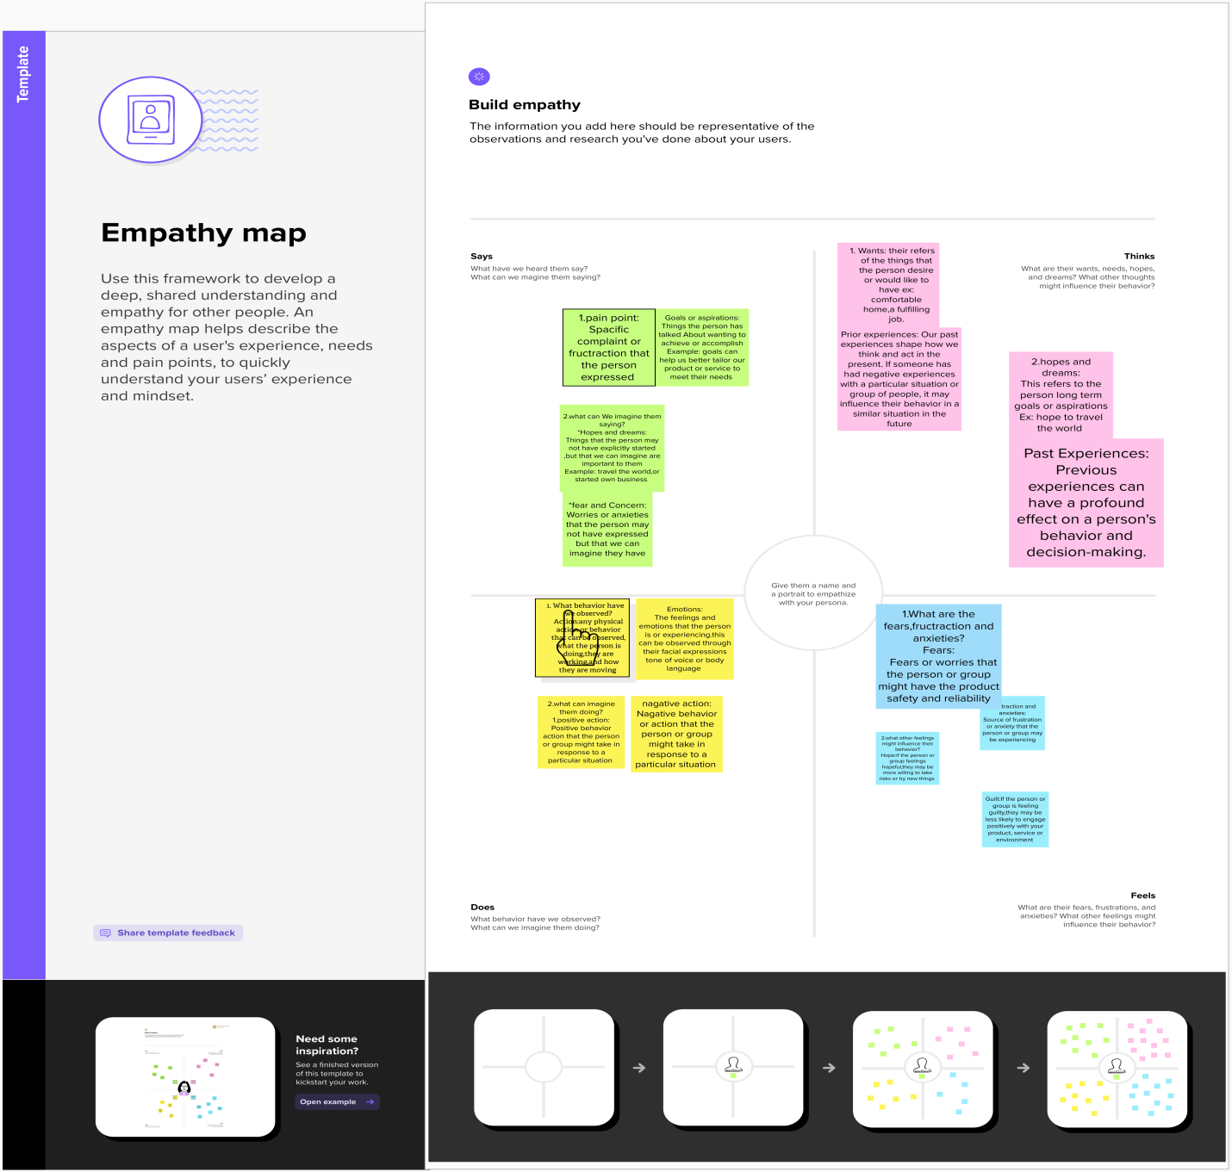

IDEATION & BRAINSTORMING MAP

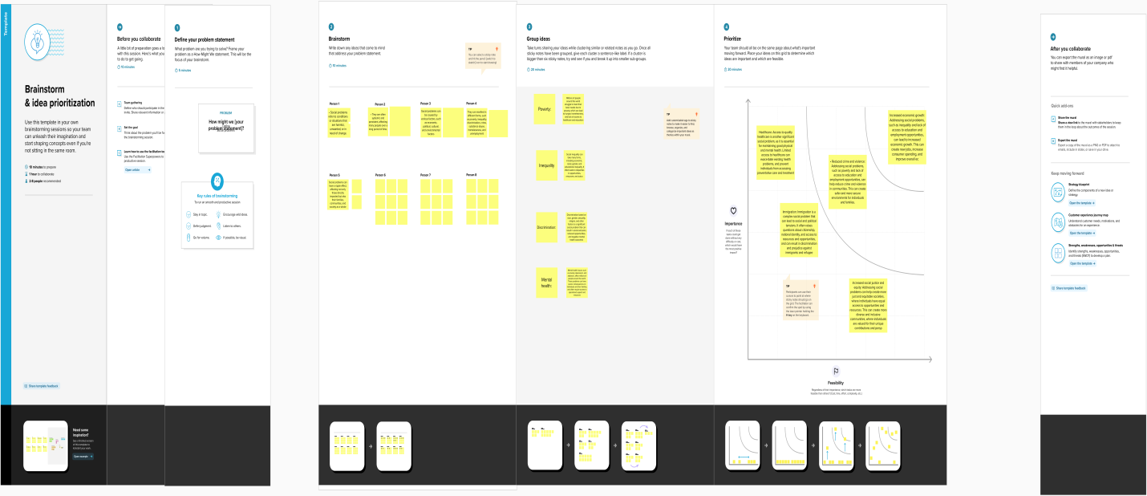

RESULT

Data model

Object name filed in object

custom object. Display/tracking

 text.

1) Dispatched

2) Expected date of delivery  
 3) Tracking Id

4) Sales order

Application  app manager

new lightning app.

desktop & mobile

Custom Page layouts 1) Warehouse page layout

2) Sales order layout

3) Dispatch/Tracking layout

Creation of user new user

user license of salesforce

.  standard platform profile

 check the box

**Validation Rule** Account object.

 LEFT(Phone, 1) <> "+".

Phone number  + (country code).

### Report Warehouses

warehouse name and stock available

 stock availability.

### .

Dashboard stock availability

donut chart

default values.

ACTIVITY AND SCREEN SHOT

MILESTONE-1

CREATION OF SALES FORCE DEVELOPER ACCOUNT

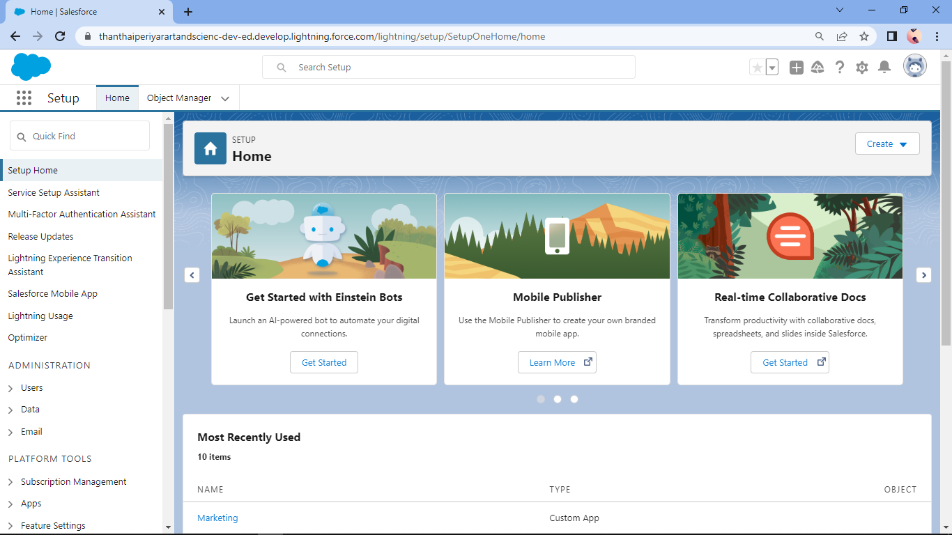

DESCRIPTION

* TO CREATE AN ACCOUNT ON SALES FORCE ORG
* AFTER LOGIN TO SALES FORCE ACCOUNT ENTER USER NAME & PASSWORD
* AFTER LOGIN THIS HOME PAGE YOU WILL START THE PROJECT

MILE STONE -2

OBJECTS

ACTIVETY-1

CREATION OF OBJECT DISPATCH / TRACKING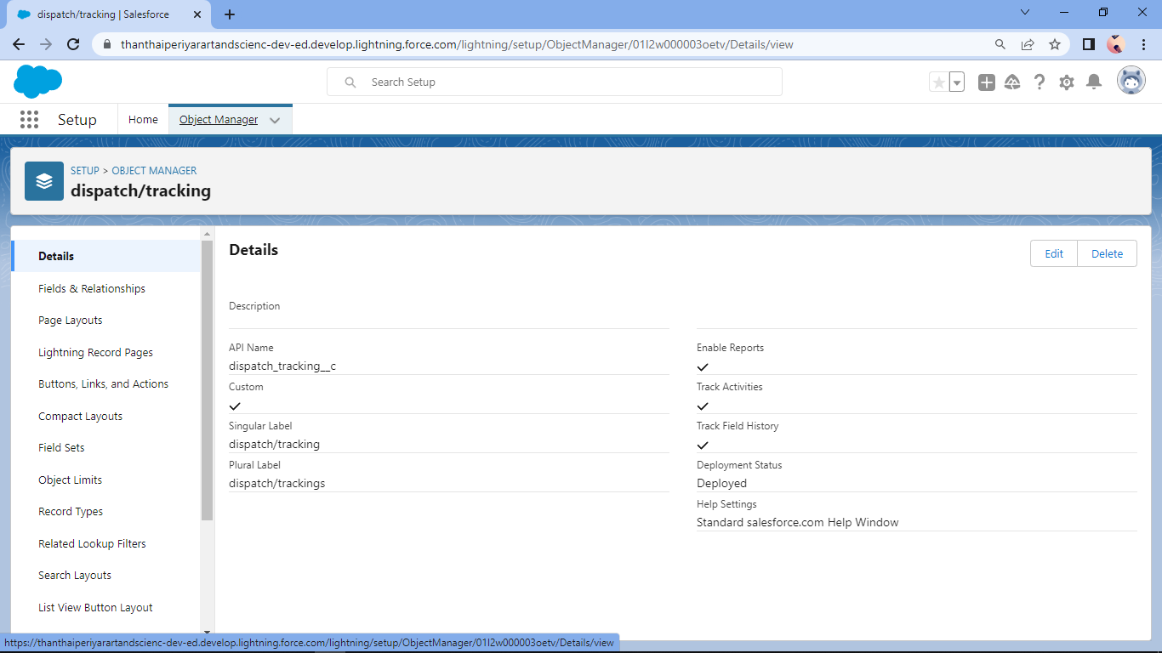

ACTIVETY-2

FIELDAS AVAILAVLE ON DISPATCH/TRACKING

MILESTONE-3

RELATION SHIP B/W OBJECT

ACTIVETY-1

CREATION OF RELATION SHIP B/W OBJECT

MILESTONE-4

APPLICATION

ACTIVITY -1

CREATION OF APPLICATION

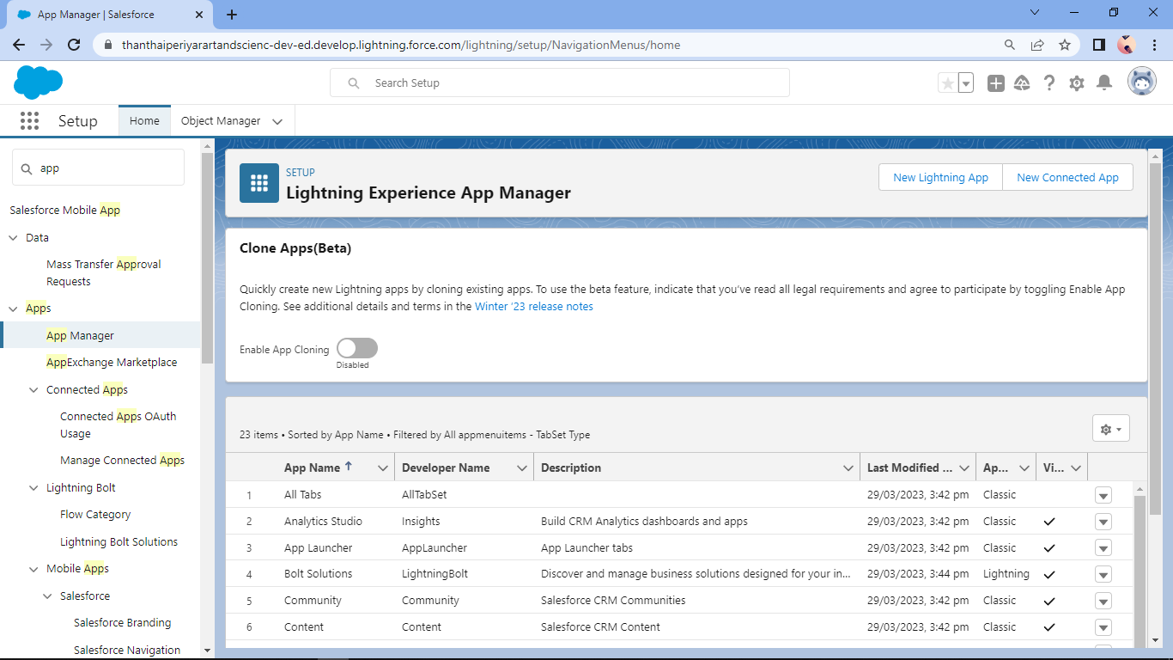

MILESTONE-5

LAYOUT

ACTIVITY -1

CREATION OF CUSTOM TAB

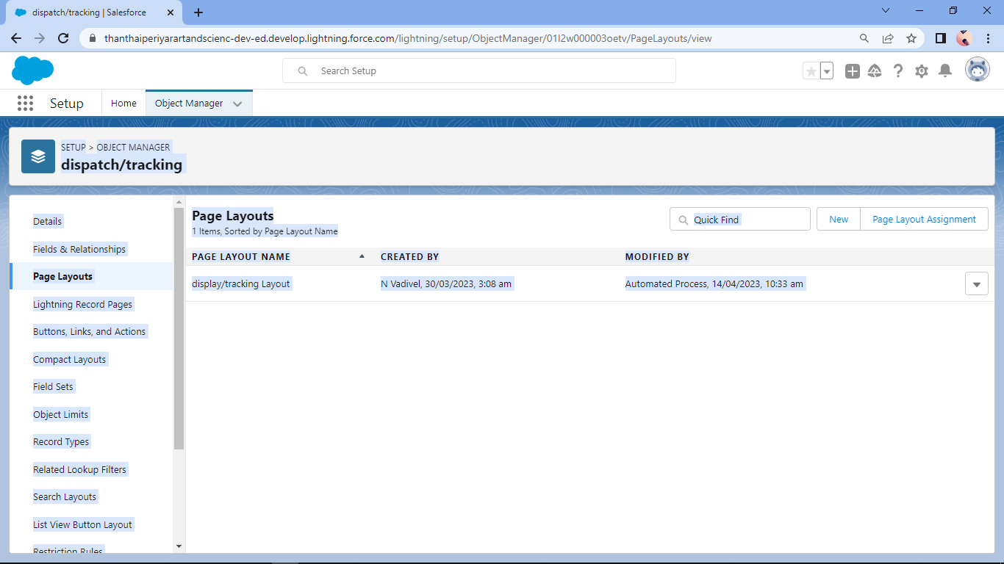

MILESTONE-6

USER

ACTIVETY-1

CREATION OF USER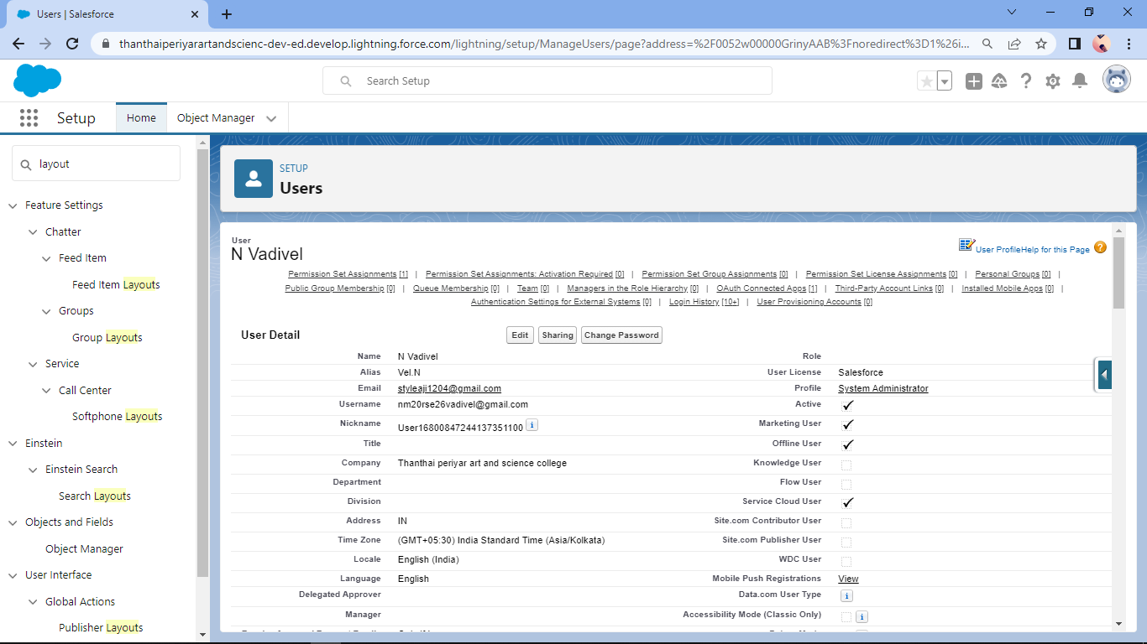

MILESTONE-7

VALIDATION RULE

ACTIVETY-1

CRETION VALIDATION RULE

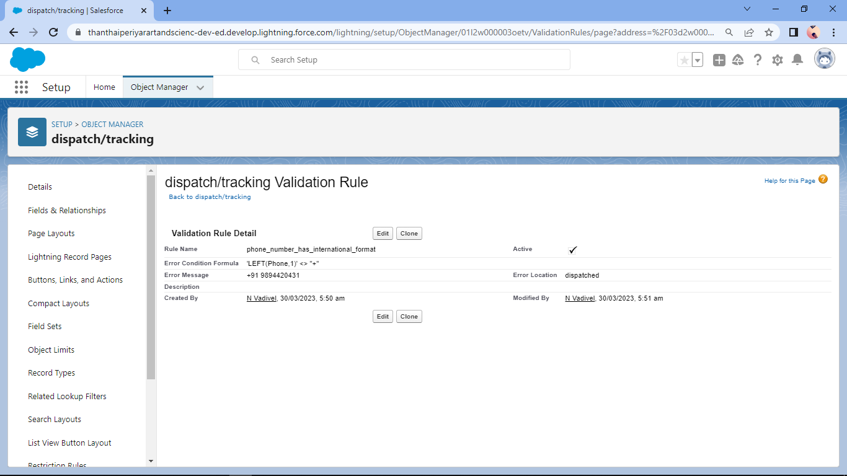

ACTIVETY-2

CREATION OF CROOSE OBJECT

MILESTONE-7

ACTIVETY-1

CREATION OF REPORT 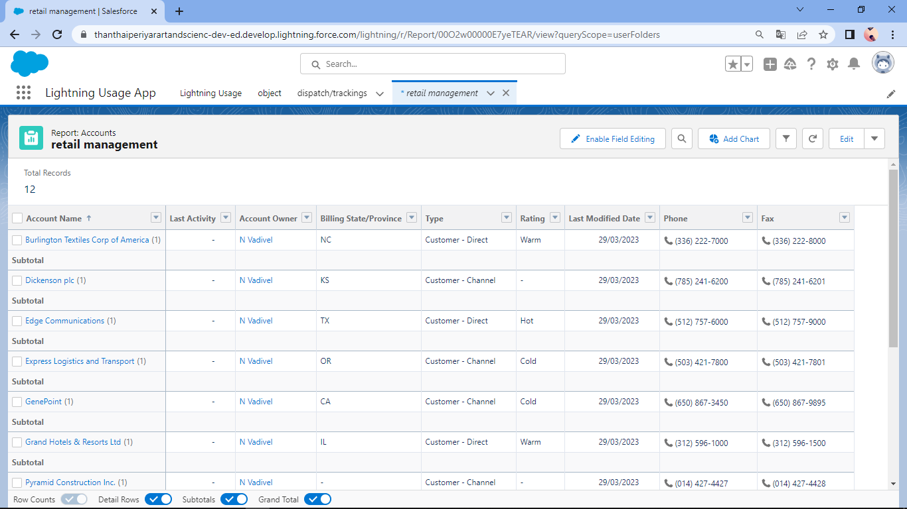

MILESTONE-8

DASHBOARDS

ACTIVETY-1

CREATION OF DASHBOARDS 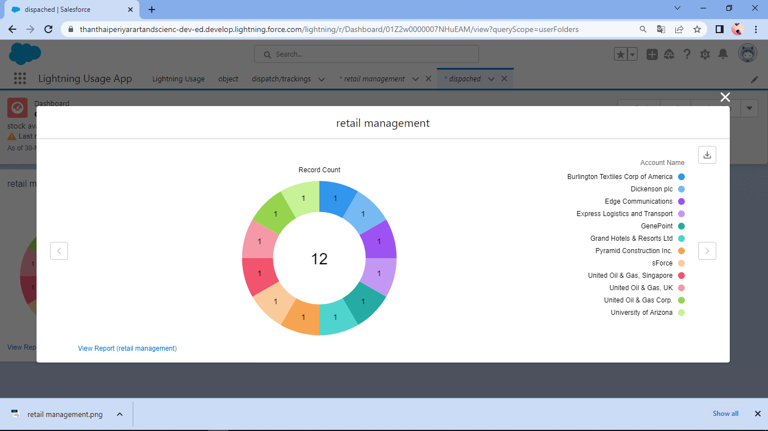

TRAILHEAD PROFILE PUBLIC URL:

Team leader : https://trailblazer.me/id/nvadivel4

Team member-1:trailblazer.me/id/gomag2

Team member-2:https:// trailblazer.me/id/kthangaiya

Team member-3: https:// trailblazer.me/id/shivasri20rse38

Team member-4:

Advantages:

Salesforce for retail management applications can help retailers to improve their sales performance, enhance customer engagement, streamline their operations, and make data-driven decisions.

Disadvanteges:

One potential disadvantage of using Salesforce for retail management applications is that it can be a complex and sophisticated platform, which may require significant training and expertise to use effectively. This can make it challenging for smaller retailers with limited resources to implement and maintain Salesforce solutions

Application:

retail management application using Salesforce can help retailers to improve their sales performance, enhance customer engagement, streamline their operations, and make data-driven decisions.

Conclusion:

a retail management application using Salesforce can provide several benefits to retailers, including efficient sales management, enhanced customer engagement, streamlined inventory management, improved reporting and analytics, and integration with other systems. However, it may also have some potential disadvantages, such as high costs and complexity. Despite these challenges, retailers can leverage the power of Salesforce to optimize their operations, drive sales, and improve customer satisfaction.

Future scope:

the future scope of a retail management application using Salesforce is bright, as the platform continues to innovate and provide retailers with new tools and capabilities to optimize their operations, drive sales, and improve customer satisfaction.